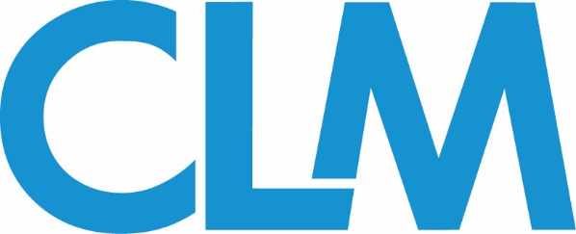
Insurance Coverage Committee
Meeting Agenda, September 2020
Lead Chairs: Michele Wojcik, Mitch Orpett
Conference
Registration is now open for the 2020 CLM Focus (December) Virtual Conference. There is no cost to attend, and CE credit will be provided for accredited presentations. See Insurance Coverage presentations below:
- Revisiting Extrinsic Evidence in Insurance Coverage Cases
- The Changing Climate of an Insurer's Duty to Defend: Recent Exceptions and Avoiding Traps for Bad Faith -
- Social Accountability in the Boardroom: Good for Business or Just Creating New Headaches for Professional Lines Carriers?
- Property Conditions: Let's Tango!
- “Don’t Lose My Number” – Cell Phone Claims: Liability & Coverage Issues
Conference Subcommittee co-chairs:
Alex Niederman (alex.niederman@ironshore.com)
Karen Ludden (kludden@dflaw.com)
Lea Kapral (lea.kapral@acuity.com)
Jasmina Richter (Jasmina.Richter@Sandersparks.com)
Michele Wojcik (liaison)
Webinars
! The Insurance Coverage Committee is looking to host one more webinar for the 2020 calendar year! CLM offers credit-bearing webinars to all members. Please see webinar details below and reach out to the co-chairs or the committee’s CLM Liaison if you have interest in co-presenting:

CE Credit-bearing Webinars:
  - Last 1 hour (50 minutes of content, 10 minutes for Q&A).
  - Led by 2-4 co-presenters
    - (a) Must have equal or more CLM Fellows (industry professionals) to CLM Members (outside counsel); (b) one Vendor Fellow allowed; (c) must all be signed up with CLM
  - Due 60-90 days before webinar:
    - Confirmed co-presenters
    - Outline
    - CE questions (Ethics or General)
    - Narrative

Webinar Subcommittee co-chairs:
Jo Allison Stasney (jstasney@thompsoncoe.com)
Michael Young (mly@heplerbroom.com)
Mitch Orpett (liaison)
Publications
If you are interested in drafting articles, please note:
- Columns should be between 900-1,100
- Each column should contain a suggested headline as well as bylines for the authors.
- All columns should be co-written by one CLM member (outside counsel) and one CLM fellow (industry/vendor rep)

Each column should be delivered 4-6 weeks in advance of the issue month:
Upcoming deadline:
December Print Issue: Due October 23, 2020

Questions? Concerns? - Email CLM Magazine Executive Editor Eric Gilkey at eric.gilkey@theclm.org.

You may also contact the
Publication subcommittee co-chairs:
Richard Allison (rallison@bmico.com)
Brian Bassett (bbassett@traublieberman.com)
Robert Usinger (rusinger@onebeacon.com)
Mitch Orpett (liaison)

Wiki
CLM’s Wiki Pages supplies a vast repository of valuable claims handling resources organized by state. The Insurance Coverage committee is seeking more assistance and 1-2 more co-chairs to assist in drafting articles for the committee.
**you might get email/call about status of Wiki; if you’ve committed to doing a state, come to me or co-chairs; update them

Please note:
- If you co-author a Wiki article, your name and firm name will be on the published article
- Attorneys may have the opportunity to get CLE credit (depends on your state; credit not given through CLM)

Wiki Subcommittee co-chairs:
Taylor Rawal (trawal@secura.net)
Seth Friedman (seth.friedman@lewisbrisbois.com)
Michele Wojcik (liaison)

Please take a moment to complete this brief survey. Thank you!

NEXT CALL: Scheduled for Monday, November 2nd at 4:00 pm EST. Members will be notified if the call is scheduled or canceled.

