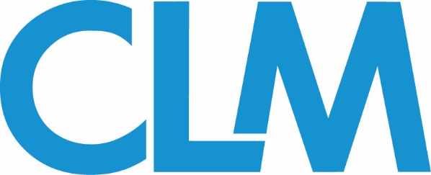

Cannabis Committee Conference Call
Wednesday, May 20th, 1:00 pm EST
Meeting Agenda
Webinars
CLM is now only offering credit-bearing webinars! Please see webinar details below and reach out to the co-chairs or the committee’s CLM Liaison if you have interest in presenting:

CE Credit-bearing Webinars:
  - Last 1 hour (with an additional 10 minutes for Q&A).
  - Led by 2-4 co-presenters (must be signed up with CLM)
  - Due 90 days before webinar:
    - Confirmed co-presenters
    - Outline
    - CE questions (Ethics or General)
    - Narrative
Upcoming webinars:
- June 10th: The Future of Specialty Lines in the Cannabis and CBD Space - CE PROVIDED
- August 12th: Prescriptions and Dispensaries
  - Finalized title, description, and co-presenters needed

Webinar Subcommittee co-chairs:
Richard Dowd - rdowd@atlas-fin.com
Ron Mazariegos (liaison) Ronald.Mazariegos@arrowpointcap.com
Conference
2020 CLM Focus (November) Conference - November 4-5 in Washington, DC.
Session proposal portal closes Friday, May 29th. You may submit a proposal on any cannabis-related topic of your choice, or select from one of the suggested topics below:

- CBD and Hemp - updates on FDA guidelines, etc.
- Marijuana claims involving class actions- investor claims and/or marketing and implication with FDA regs
- Claims Issues related to Marijuana Industry
- Challenges of cannabis specialty lines
- General overview of state of the law/current developments in cannabis law

Committee Conference Subcommittee co-chairs:
Richard Baron (rbaron@fbmjlaw.com)
Johan Obregon - jobregon@callahanfusco.com
Fred Perez - fred.perez@mclarens.com
Kara Thorvaldsen (liaison) - Kara.Thorvaldsen@wilsonelser.com
Publications
The Publications subcommittee will produce content for the Cannabis committee’s monthly e-newsletter within the CLM Magazine.

- Columns should be between 900-1,100
- Each column should contain a suggested headline as well as bylines for the authors.
- All columns should be co-written by one CLM member (outside counsel) and one CLM fellow (industry/vendor rep)

July eNews: June 12, 2020  August eNews: July 10, 2020  September eNews: August 7, 2020 | October eNews: September 10, 2020  November eNews: October 9, 2020  December eNews: November 13, 2020
Each column should be delivered 2-4 weeks in advance of the eNews month. Suggested deadlines:

Publication Subcommittee Co-Chairs:
Leslie Rutledge - leslie.rutledge@aig.com
Stacey Jackson - Stacey@goldenbear.com
Richard Baron - rbaron@fbmjlaw.com
Larry Powers - lpowers@hoaglandlongo.com
Ron Mazariegos (liaison) Ronald.Mazariegos@arrowpointcap.com

You may also email the CLM Magazine Executive Editor Eric Gilkey at eric.gilkey@theclm.org
for more information.

NEXT CALL: Scheduled for Wednesday, July 15th at 1:00 pm EST. Committee members will be notified if the call is rescheduled or cancelled.

