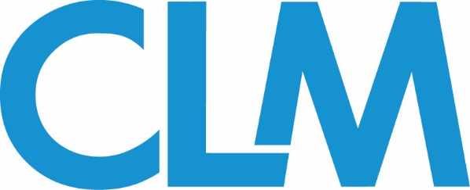

ADR Committee Conference Call
Wednesday May 2, 2018
Agenda

I. Overview - Annual Conference- Houston
-Goals for 2018
-Conference Opportunities
-Dismantle of Adjuster Training Courses

II. Committee Membership and Structure
-Chair: Lisa Unger, Markel Corp. (lunger@markelcorp.com)

-Co-Chairs:
Robert Freedman, Tharpe & Howell (rfreedman@tharpe-howell.com)
Richard Dowd, Global Liberty Insurance Company of NY (rdowd@atlas-fin.com)
Cayce Greiner, Tyson Mendes (CGreiner@TysonMendes.com)
Kelly Hopper Moore, CSE (khoppermoore@cseinsurance.com)

Subcommittees:
-Committee Conference: Robert Freedman- Liaison; Lisa Unger, Justin Callaway, Joe Hassinger, and Ralph Woodard- Co-Chairs.
-Membership: Lisa Unger –Liaison. Need Co-Chairs
-Publication/Magazine: Cayce Grenier and Kelly Hopper Moore- Liaisons; David Standish, Patricia Walker– Co-Chairs
-Webinar Development: Richard Dowd - Liaison; Paul Gordon, David Heller- Co-Chairs

III. Sub-Committee Updates
IV. Webinars- Two webinars scheduled for 2018
March 28, 2018 - Cost Management- Outside the Box Use of Court Analysis.
Presenters Dr. Rachel York Colangelo, Magna Legal Services, LLC and Anthony Fattoruso, Atlas Financial Holdings, Inc.

September 19, 2018- Work in Progress (1 Fellow / 1 Member)
*** If interested in presenting a future webinar, please contact Rich Dowd.
To access Upcoming and Archived Webinars: Go to the CLM Website and sign in. Click Events Tab (on top right Menu Bar), Select Webinar (from list of items on the left side), then Select from Upcoming or Archived events. To review an Archived event, select the event and follow the link to Download.
https://www.theclm.org/Webinars

V. Remaining Quarterly Calls 2018
Wednesday, August 1, 2018- 12pm Eastern/ 9am Pacific
Wednesday, November 7, 2018 - 12pm Eastern/ 9am Pacific

VI. CLM Magazine Articles- There are three (3) CLM Magazine issues in 2018 that will include ADR-related articles. This would be the opportunity for the committee to submit articles. They should be co-authored (1 Fellow / 1 Member).

-April Issue- Just Released- Making Mediation Count by: Daniel Fallon http://clmmag.theclm.org/home/article/Making-Mediation-Count?tick=1273209010221336454&dm_i=37P3,P7UE,2S1PX1,2KUZV,1

-July Issue (due May 15)

-October Issue (due Aug 21)

***There are other months that we are welcome to submit articles. The deadlines are:

-August Issue: (Due June 20)
-September Issue: (Due July 17)
-November Issue: (Due September 19)
-December Issue: (Due October 23)

VII. Comments… Ideas….Questions???

