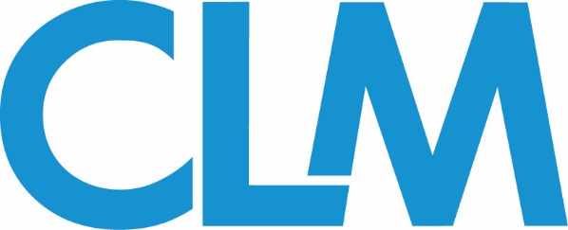

Municipal Law Committee Conference Call
Wednesday, August 28th, 2:00 pm EST
Meeting Agenda
Ph#: 267-930-4000; Access Code: 471-944-455#
Webinars
Upcoming webinar:
Jury Selection in Post Ferguson Law Enforcement Excessive Force Cases - Wednesday, Sept. 11th ,12:00 pm EST
Speakers:
- Gordon Vaughan – Attorney, Vaughan & DeMuro
- Shelley Spiecker – Senior Litigation Consultant, Persuasion Strategies
- Sarah Schmitz – Claims Examiner, OneBeacon Insurance Group

Reserve your Webinar seat now at:
https://event.on24.com/wcc/r/2062511/4D093FDE8B52B545CC6DF92544076764

- Standard CLM Webinars: Last 30 minutes followed by a 10-minute Q&A. Webinars are led by 2 co-presenters – 1 CLM Fellow, 1 CLM Member – who must be finalized and provide a brief description at least 90 days in advance of the webinar.
- CE Credit-bearing Webinars: Last 1 hour (with time for Q&A [10-15 minutes]). These webinars are led by 2-4 co-presenters with 1-2 CLM Members and 1-3 CLM Fellows. An outline, title, brief description and finalized co-presenters must be submitted at least 90 days prior to the webinar.

If you are interested in co-presenting a webinar, please reach out to the
Webinar Subcommittee co-chairs:
Wayne Melnick (wmelnick@fmglaw.com)
Gordon Vaughan (gvaughan@vaughandemuro.com)
Conference
Don’t forget to register for the 2019 Southeast Conference, October 3-4 in Orlando, FL. Municipal Law sessions include:

- Everything You Want to Know about “Free(ing) the Nipple”, But Were Afraid to Ask in Light of Recent Opinions
- The Legal Issues Concerning School Resource Officers: Arming School Resource Officers and the Policing of Students
- Safeguarding Against the Unpredictable: Negligent Security and Active Shooter Claims
- Recent Developments in Qualified Immunity for Law Enforcement Officers

Sessions 1 and 4 will need an additional speaker, preferably a CLM Fellow (insurance industry professional). If you are interested in participating on a panel for this conference, please reach out to Khadijah Johnson at Khadijah.Johnson@theclm.org

-For more information on these presentations, please visit the CLM website from this link here or navigate to www.TheCLM.org > Events > 2019 Southeast Conference

You may also contact the
Committee Conference Subcommittee co-chairs:

Greg Gilliam (Greg@sorsaschools.org)
Starr Kincaid (skincaid@mmrma.org)
Jayne Spies (jspies@omag.org)
Steven Stern (sstern@sokoloffstern.com)
Publications
Columns should be between 900-1,100
- Each column should contain a suggested headline as well as bylines for the authors.
- All columns should be co-written by one CLM member (outside counsel) and one CLM fellow (industry/vendor rep)

Deadline:
Each column should be delivered 4-6 weeks in advance of the issue month. Suggested deadlines include:
December Print Issue: Due October 23, 2019
Questions? Concerns? - Email CLM Magazine Executive Editor Eric Gilkey at eric.gilkey@theclm.org

You may also contact the
Publication subcommittee co-chairs:

Dennis Mitchell (demitchell@bickmore.net)
William Oberts (wboberts@tribler.com)
William Salzer (wsalzer@swartzcampbell.com)
Wiki
The Wiki subcommittee is seeking assistance (or new co-chairs) to help lead the subcommittee and prepare Wiki Pages.

Please note:
- If you co-author a Wiki article, your name and firm name will be on the published article
- Attorneys may have the opportunity to get CLE credit (depends on your state; credit not given through CLM)

If you would like to volunteer to review or co-author Wiki articles, please contact the committee’s main co-chairs below:
Municipal Law Co-Chairs:
Wayne Melnick (wmelnick@fmglaw.com)
Sarah Schmitz (sschmitz@onebeacongov.com)
Jayne Spies (jspies@omag.org)
Steven Stern (sstern@sokoloffstern.com)

NEXT CALL: Scheduled for Wednesday, November 13th at 2:00 pm EST. Members will be notified if the call is rescheduled or cancelled.

